NEWS RELEASE
11.07.25, for immediate release

National cross country championships to return to North East after 13 years
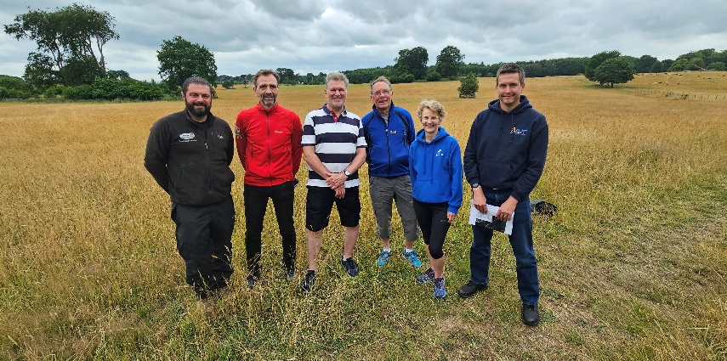

Sedgefield in County Durham will host a major national athletics event for the first time next year. The English Cross Country Association (ECCA) has confirmed that the 2026 English National Cross Country Championships will be held in Hardwick East Park. Organised in partnership with Sedgefield Harriers and supported by Durham County Council, the championships are sponsored by SportsShoes.com and will take place on Saturday 21 February. The event was last staged in North East England in 2013 and will be returning to County Durham for the first time in 25 years.

The 2026 English National Cross Country Championships will be held in East Park, which is an area of open parkland to the east of Hardwick Park, on the edge of Sedgefield. The land is owned by Durham County Council, which has agreed for ECCA to hold the championships on the site. In recent years, East Park has been the venue for both the North Eastern Counties Cross Country Championships, in 2015 and 2021, and the Northern Cross Country Championships, in 2024. The much larger scale national event next year will use similar routes around East Park, and organisers are working with the local authority and other partners to put the necessary infrastructure and logistical support in place.

A local organising committee will work with ECCA and Durham County Council to deliver the event. Host club Sedgefield Harriers will play a prominent role in staging the championships, and will recruit

volunteers from the region to help out on the day. Local venues and businesses have already stepped forward to offer support, including Sedgefield Racecourse and Hardwick Hall Hotel. The English National Cross Country Championships attracts thousands of participants and spectators every year and will bring new visitors to the area, and a boost to the hospitality economy.

Steve Gaines, ECCA president, comments: “Sedgefield has already demonstrated that it has the ability and desire to stage major cross country events. While the English National Cross Country Championships will represent a significant step up, we know that East Park can deliver a great course and we have excellent local partners in Sedgefield Harriers and Durham County Council. ECCA, along I’m sure with event sponsor SportsShoes.com - a northern company itself - will be delighted to bring the championships back to the North East. It is a region that is passionate about sport and has a long and rich heritage of athletics, including many past race winners in these championships. Sedgefield is easy to reach from every direction, so we look forward to welcoming runners from around England for an excellent event next February.”

Sue Dobson, chair of Sedgefield Harriers, adds: “We’re delighted that ECCA has decided to bring the English National Cross Country Championships to Sedgefield. Our members know better than anyone that East Park is a great place to run, and we can’t wait to welcome fellow athletes from all over the country to find out for themselves. The championships will be a wonderful way to showcase this corner of County Durham to thousands of visitors, and demonstrate that we can put on major events here.

“These are exciting times for Sedgefield Harriers as the club celebrates its 20th birthday this year. Our senior and junior sections are both growing and I know that a large number of our members will be lining up to get involved in the championships, either as participants in one of the races, or helping us make sure that the day is a great experience for everyone who attends.”

Cllr Joe Quinn, Durham County Council’s cabinet member for resources, investment and assets, said: “We’re very excited to host the 2026 English National Cross Country Championships in one of our parks. This is a prestigious national sporting event which will give our local clubs the opportunity to take part in a huge event on their home soil. It will also help to inspire more people to be active or take up a physical activity such as running.

“Not only that, the championships will attract thousands of visitors to the region and bring with it a boost to our businesses and visitor economy. Sedgefield has a lot to offer for this event, and we look forward to welcoming people to the area next year.”

North East mayor Kim McGuinness comments: “I’m thrilled we are bringing the English National Cross Country Championships back to the North East for the first time in more than a decade.

“We want the North East to be the country’s first region of sport, and this is another amazing major event we have coming up alongside the women’s Rugby World Cup, international cricket and of course our own Great North Run.

“The North East has a long and proud tradition of distance running and hosting events like the English National Championships in Sedgefield will help inspire a new generation to follow in the footsteps of stars like Sir Brendan Foster and Mike McLeod.”

For more information about the English National Cross Country Championships, visit the ECCA website at www.englishcrosscountry.co.uk.

ends

For additional media information please contact:
Chris Lines on 07971 868329 or chris@rightlines.info.

Photo caption:
From left to right: Ross Carrick, senior parks and countryside ranger, Durham County Council; Chris Lines, member of Sedgefield Harriers and a county councillor for the Sedgefield ward; Eamonn Martin, secretary of ECCA; Steve Gaines, president of ECCA, Sue Dobson chair of Sedgefield Harriers; Mark Tallon, competition and events administrator at Northern Athletics.

