Information for new Athletes

**Sessions**

All standard sessions are on a Wednesday night at 6 pm at the Sedgefield community college sports hall. We do not operate during the school holidays.

**Minis** – Year 1 until age 8 – Head Coach **Stuart Park**

**Juniors** – Age 8+ – Head Coach **Sheree Lyons**

**Endurance** – Year 6 and above – Head Coach **David Graham**

There can be a significant step up in running from the juniors to the endurance group so we aim to move a group of juniors up at the same time so that they can support each other and do not feel overwhelmed. This group focuses on running only (main group is running, throwing and jumping). It is held outdoors except in extreme weather conditions, as it is held outside then please ensure that the athlete dresses for the weather. There are additional sessions held for the endurance group – please speak to David Graham about these.

**Registration**

Please complete the English Athletics registration form by scanning the QR code on the business card and following the instructions. This will then be put on the English Athletics system. You will receive an email with your URN (unique reference number). You can then use this to view your profile – Please keep this up to date as we use it for emergency contact details and medical information.

**Until an athlete is registered on the EA system, we ask that the parent stay during the session as we will not have this information to hand. Registration on the tablet at the start of the session does not mean EA registration.**

**Payment**

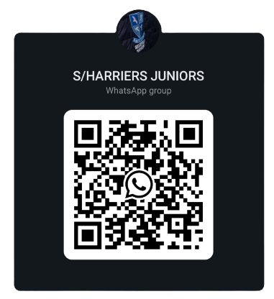English Athletics works an April-March year. If you are a current member (from the previous year), you will get an option of paying for the year (25/26 £50) or in 3 termly lots (£20). If you join in September or January the fee will be termly for the first year. For membership queries please contact [sedgefieldharrierscommittee@gmail.com](mailto:sedgefieldharrierscommittee@gmail.com).

For payment requests you will receive an email from [noreply@englandathletics.org](mailto:noreply@englandathletics.org)

**Communication**

There is a WhatsApp group for communicating between the coaches and the parents. If you scan the QR code then someone will approve legitimate requests.

There is also the Sedgefield Harriers Members Facebook page. You can request access to this. Official communication will come through the club email system – This is automatic when the EA registration is complete.

**Collection and drop off**

Sedgefield Harriers do not take and responsibility for the athletes until they have been registered for the session. Athletes are responsible for registering themselves on the tablet at the start. We use this to track attendance.

We ask that a responsible adult collects the athlete from the session. If you would like them to leave on their own then we require a consent form to be completed. Please ask at registration for one.

**Waiting list**

We currently have a waiting list for both the Minis and Juniors. Please speak to Stuart Park about getting someone added to this and they will be contacted when a place is available. We are now opening up the waiting list to pre-register for the minis session before they are in Year 1.

Due to popularity of the sessions if you do not attend for 4 consecutive weeks, we will contact you about giving up your place. We cannot hold places indefinitely but will try to accommodate all reasonable requests.

**Club Clothing**

If you would like to purchase some club clothing there are two options. Gary Forster has a selection of vests, t-shirt and other items. The email address is [kit@sedgefieldharriers.co.uk](mailto:kit@sedgefieldharriers.co.uk). You can also look and buy online at Moette – There is a direct link from the Sedgefield Harriers website [www.sedgefieldharriers.co.uk](http://www.sedgefieldharriers.co.uk)

We have a small selection of 2nd hand clothing. Please speak to a coach about this.

**Welfare Officer**

We have two Club Welfare Officer’s - Sheree Lyons (Head Coach for juniors), and Matt Cooke.